Image Schemas and Lexicons:
A comparison between two Lexical Networks.

L J Old
8-10-91

Abstract: This paper compares the "radial category" of image schemas derived for the polysemous word "over", by Brugman and Lakoff, 1987, with the lexical networks for "over" derived by the author, from Roget's International Thesaurus, 3rd Edition, and The Oxford English Dictionary, 2nd Edition.

1. Introduction:

Polysemy is the case where a word may have several, related, senses. This is in contrast to homography, where a single lexical form may have several, semantically unrelated meanings. For example lead may have the sense of induce or precede, where the senses are related and therefore examples of polysemy. On the other hand, lead (precede) and lead (the heavy metal) are not directly related.

Words which have related meanings may be arranged in a network or graph of associations where the relationships between any two senses are represented by an arc or link, and the particular senses are represented by nodes. That allows the formation of a spatial representation of the set of senses. In these "maps" homographic words should not appear as directly related, whereas polysemous words should appear as a set of related senses.

In this paper I will compare and at times contrast the graph or network resulting from the formation of sense nodes and relatedness arcs derived by Brugman and Lakoff (1987), that resulting from the output from an automated version of Roget's International Thesaurus (RIT), and, for the purpose of arbitration, that derived from the Oxford English Dictionary (OED).

2. Networks, Senses and Words:

My analysis of RIT and OED indicates that words which occur in more than one sense may serve to represent links amongst those senses. The resulting networks tend to force senses which have many words shared with other senses into a central position. I shall refer to the shared words as "link words", the count of shared words as "link counts", and the focal senses as "central senses". Network links may be labelled by words or word counts. Other, alternative methods of isolating senses or concepts and connections amongst them, are available. For example Bryan (1973).

2.1 Brugman and Lakoff:

Brugman and Lakoff use the term "radial category" to describe the map which results from the spatial representation of the senses of a polysemous word (refer to Figure 1. for the complete radial category for the word "over"). The central node or sense is considered to be the main meaning of the word, while the other senses are transformations of the central sense, or transformations of transformations. Of the many senses Brugman and Lakoff discuss in their paper, they chose twenty four as nodes in their network. They define their senses by using example phrases plus an intuition as to the primary interpretation or atomic or indivisible meaning of the phrase(s).
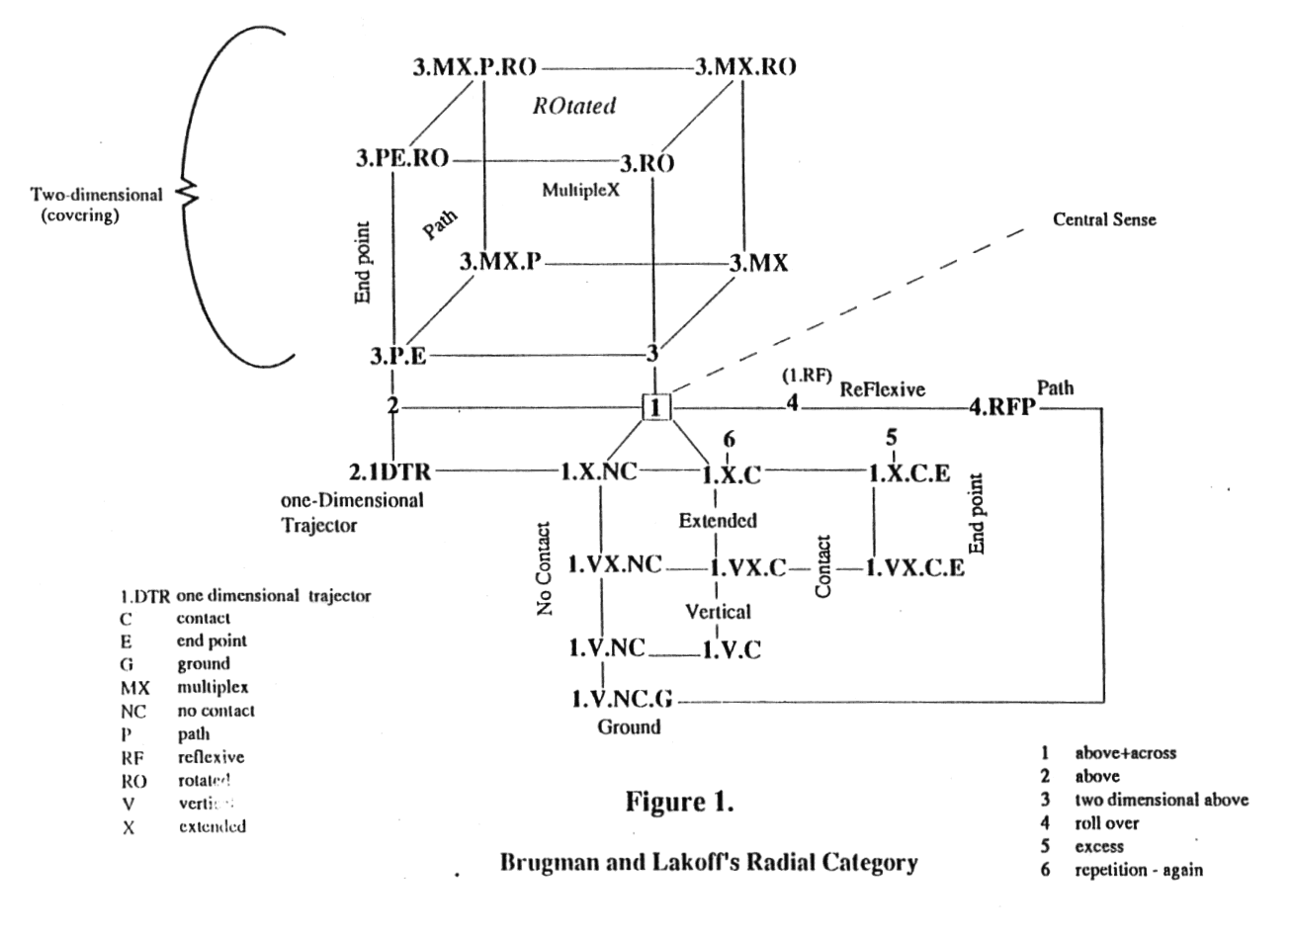
They describe each sense in terms of an intuitive "image schema" which may be represented as a diagram involving vectors (trajectors), landmarks, planes, et cetera, and note that image schemas cannot be imaged concretely, but that they "structure images". They encode the senses as nodes using symbols to indicate the discriminant features of the image schema which the node represents. These are used as labels to identify the sense (node) in the graph and to indicate a transformation which has taken place (i.e., to discriminate each sense from its "more central" sense). These variations Brugman and Lakoff (B&L p. 482) refer to as "special cases". For example, X for "extended" and E for "end point involved" (as opposed to no end point in the previous sense), C for "contact involved" (as opposed to NC for "no contact involved" in the previous sense), and R for "rotated".

Examination suggests that each transformation code can be characterized by a single word. For example senses labelled with C (contact) may be characterized by the word "on" while NC (no contact) may be characterized by the absence of "on". I imagine that words were (at least partly) the source or basis of these codes. I don't wish to reverse-engineer these encodings, but simply wish to point out that the RIT and OED maps described later and which use words rather than transformations of image schemas, have a shared basis at some level.

Brugman and Lakoff chose their links on the basis of:

i) shared information,
ii) general-to-specific case, and
iii) concrete-to-metaphoric case (B&L p. 478).

Their links are neutral in that they do not have weights or labels. They indicate a transformation (related subschemas), or similarity (a shared subschema) (B&L p. 488).

2.2 RIT:

A Category in RIT is a concept or "notion" which represents a range of quite different words. For example Category 171, labelled Influence, represents a range of different words with influence-related meanings. These words are organized into groups of words of more closely related meanings (called here semi-colon groups, as they are separated by semi-colons). The words in semi-colon groups may be referred to as synonyms (for example, "lead, induce; dispose, sway, incline") i.e., all words within a Category contain some sense of the Category-level concept. In this study the RIT senses (nodes) were chosen in terms of semi-colon groups. The Category-level concepts were not used to form links or nodes in the network but were retained as node identifiers (labels).

To obtain the RIT data for this study all words and phrases contained in semi-colon groups which held an occurrence of the word "over" as a single lexical entry (as opposed to "over"-containing phrases) were selected as representing senses of "over". Twenty-two sense nodes resulted from using this method.

The words selected as links in the network were those which repeated in two or more semi-colon groups containing the word "over". For example, "on" co-occurring with "over" in two semi-colon groups (e.g., "over, on, on top of", and "over, on, upon") implies a closer association between the two semi-colon groups than that implied had "over" been the only word shared by the two groups i.e., the semi-colon groups "over, extra, remaining" and "over, on, upon", do not share a second word and are not closely related.

2.3 OED:

The same method was used to relate OED senses. But note the following:-

a. the OED sense definitions were heavily edited by me prior to processing. Meta-level descriptions and words such as "in the sense of", "for example", "leading into notions of", "see GET 45", "figurative", "obsolete" and so on, were eliminated (though the data was kept for later examination).

b. there were more than a thousand links between senses which shared at least two words. The number of resulting links were too many to transfer easily to a graphical map/network. Consequently the map shows only links between senses which share three or more words. This loss of information is not such a problem as it might seem, however, as some senses share words which are used in different ways. For example senses such as the division operator in arithmetic a/b (pronounced a over b) uses words such as in, as in, "A in terms of B" in its definition. Other senses use in, as in "in addition", "in excess of" and so on. A criterion of "must have three words in common" does lose information, but errs on the side of caution.

c. any assumption that the study of word-sharing amongst senses within RIT and OED (respectively) would produce analogous results is faulted. RIT is organized on the basis of groups of synonyms and related senses fairly consistently have words in common (if this is not so at the semi-colon group level, then it is usually the case that the senses share the same category label). OED, on the other hand, is organized into descriptive sentences. The problem which arises for OED analysis is that one sense may be described using one set of appropriate words while another very similar sense may be described by a set of completely different, but synonymous words. The result is that there is no intersection or overlap of the two word sets -- yet they are related. It is even more likely that distant senses, though somewhat related, will be disjoint. The method used does, however, produce useful results.

d. a second problem with sentence definitions and what appear to be ad hoc groupings in OED is that several senses may be included in one sense heading. The headings tend to be Roman numerals with sub-headings of Arabic numerals and finer discriminations (if required) identified by lower case alphabet letters. However, in OED II 3 (adverb) there are at least three senses:

{"... [1] motion that passes or crosses above ... [the same sense but] [2] rising on one side and descending on the other;... [3] passing above and beyond instead of hitting or reaching, and so figuratively of going beyond, exaggeration."}.

This sense was edited manually by me into three senses.

One further note on the OED data: In order to provide a comparison between the RIT data and the OED data an attempt was made to build a network of the OED data at the main senses (category or Roman numeral) level using words (instead of word counts) to represent the relationships between those senses. If a word appeared in three or more senses a labelled circle was used to enclose the senses, in the way that a Venn diagram encloses a set. Though the OED definitions of the word "over" (eighty seven, in all) include adjectival, substantive and verb forms, only the OED words from the data set which participated in the definition of adverbial or prepositional senses (approximately sixty senses), were used for this network. The result is shown in Figure 2.

Clearly this is not subject to quick interpretation. However, note that:

1. Roman numeral categories/senses IV (preposition) and II (adverb) have been forced to a central position, perhaps suggesting that the central sense of "over" lies in this vicinity or is shared by the two senses.

2. the intersection of the two bold-face circles (labelled "position/motion" and "across/other/side") point to a shared sense between IV (preposition) and II (adverb)

3. the words "above", "beyond" and "pass" are pervasive (utilized by many sense definitions) suggesting perhaps that they are elementary to the meaning of "over".
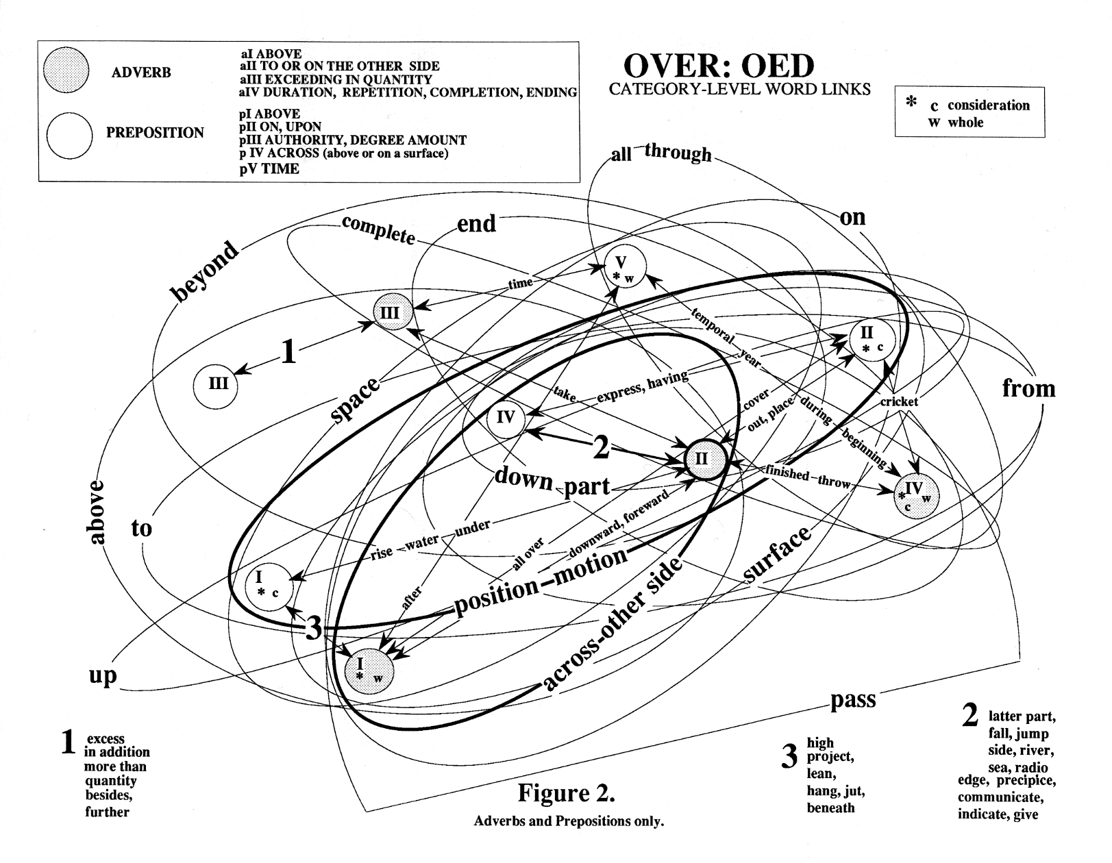
The general orientating effect of this diagram on the main senses of the OED was retained to form the basis of all future figures derived from the OED data. For example, the OED cross-references shown in Figure 3.

Note that all three networks discussed rely on shared information as the method of identifying similarity links between sense nodes.

3 The Central Sense(s):

3.1 Introspection/Ad hoc:

Possibly the first interpretation of "over" given by most people is "higher (than)" or "above" (no extension). Preliminary sampling suggests that over is discriminated from above in that, strictly speaking, above means "higher, but not necessarily directly above", while (again strictly speaking) over means that the subject is upward in relation to, and intersecting the orthographic projection (vertical projection) of the image of the object. That is, it is possible to be above but yet not over. This last statement is discussed further in a Section 5.5.

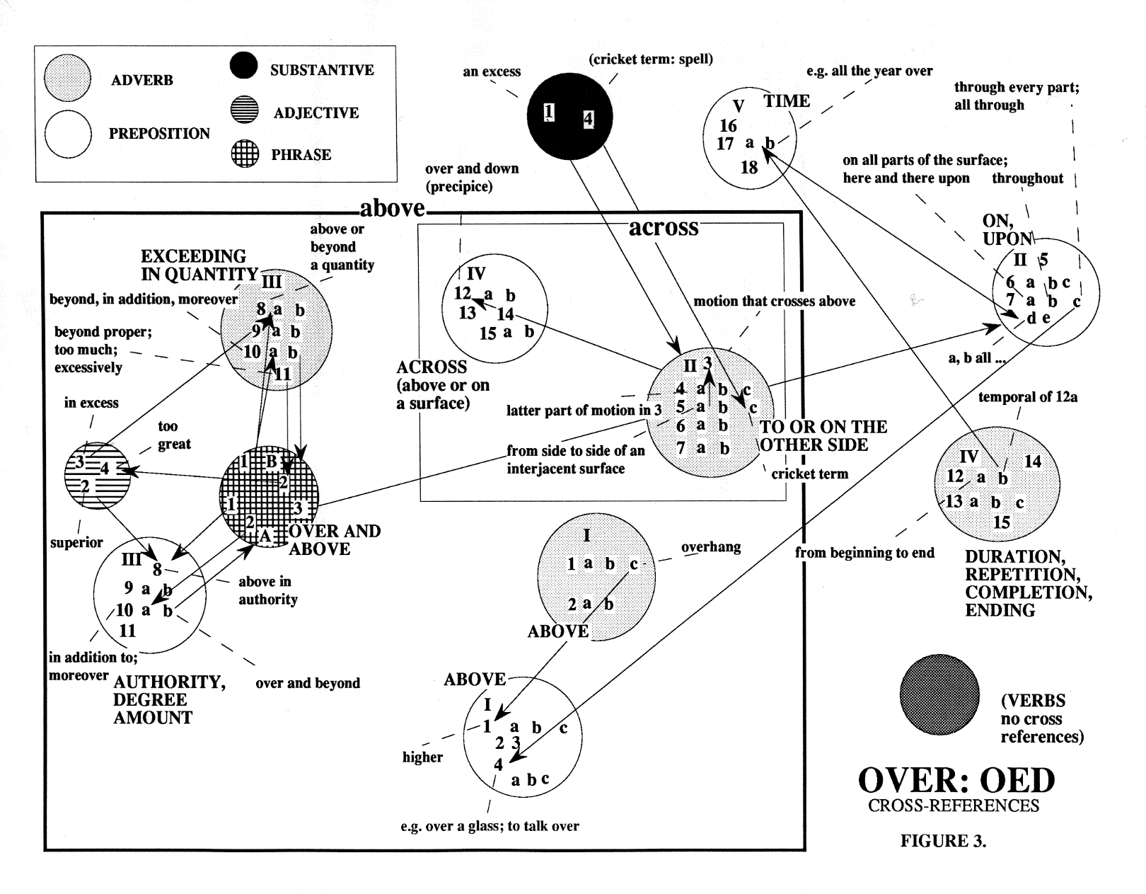
3.2 Brugman and Lakoff:

Brugman and Lakoff define the central sense of "over" as the combination of the "elements of above and across". There is an implication of neutrality in the central sense as they define it, in that it may neither explicitly have nor not have a particular attribute in common with those senses which surround it.

3.3 RIT:

Though both the "across" and "above" senses or interpretations are represented in the network extracted from RIT the central sense (in terms of weight of numbers of link words) is "additionality" (refer to Figure 4.) closely followed by "excess-related" senses. (Note that the connected portions of the map shown in Figure 4. correspond to one of Victor Jacuzzi's (the previous speaker's) components.
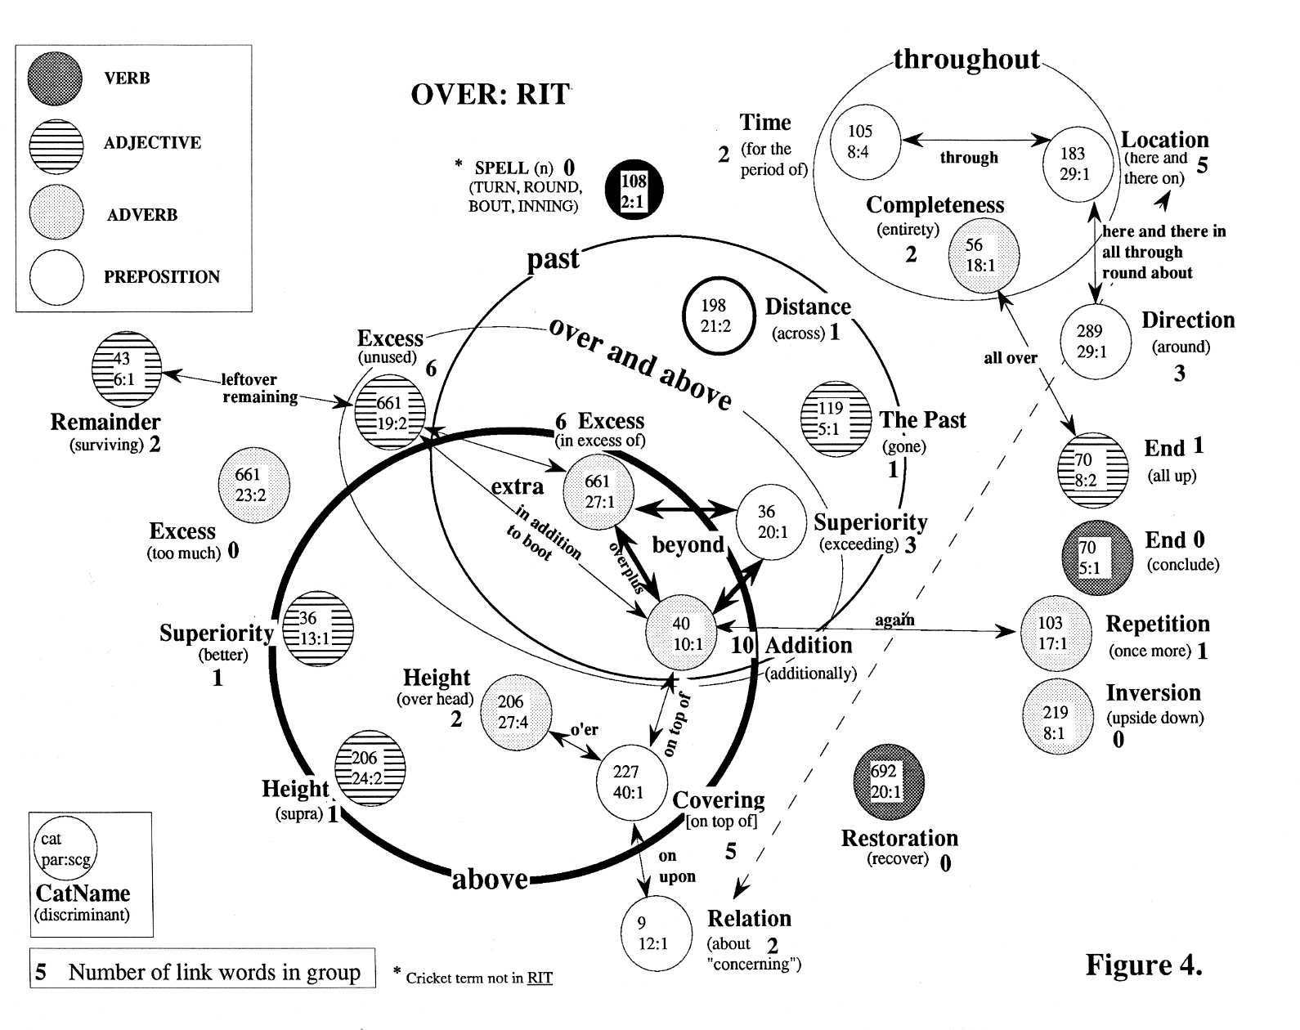
3.4 OED:

The central sense in OED, given the data extraction method (and referring to the lowest level of sense definitions -- the Arabic number and lower case letter level), appears to be Category IV, paragraph 13 (preposition). This sense involves "from side to side; across to". (Refer to Figure 5. for the network. IV 13 (preposition) is in the top central white circle). The reason for choosing this as the central sense is that it has the largest number of attachments/links in Figure 5. (i.e., six) and the largest total of link counts (22). I have summarized the link counts in Figure 6. -- the counts are located beside the sense labels.

Treating the entire circles (Category levels) as senses in their own right, and summing the incoming arcs, Category II, (adverb) ("TO OR ON THE OTHER SIDE") exceeds all others in weight. It has links to four other Category-level senses and a total count of 37 (refer again to Figure 6.).

These counts are located, underlined, beside the Category descriptions e.g., TIME 6,1 indicates that Category V (preposition) has a total count of 6 and is connected to one other Category-level sense.

It appears that "across to" summarizes the senses identified here. This closely matches Brugman and Lakoff's choice of a central sense for over and is the sense of the "across"-containing semi-colon group in RIT (refer to Figure 4., Category 198.21:2 Distance (preposition) to the top and center).
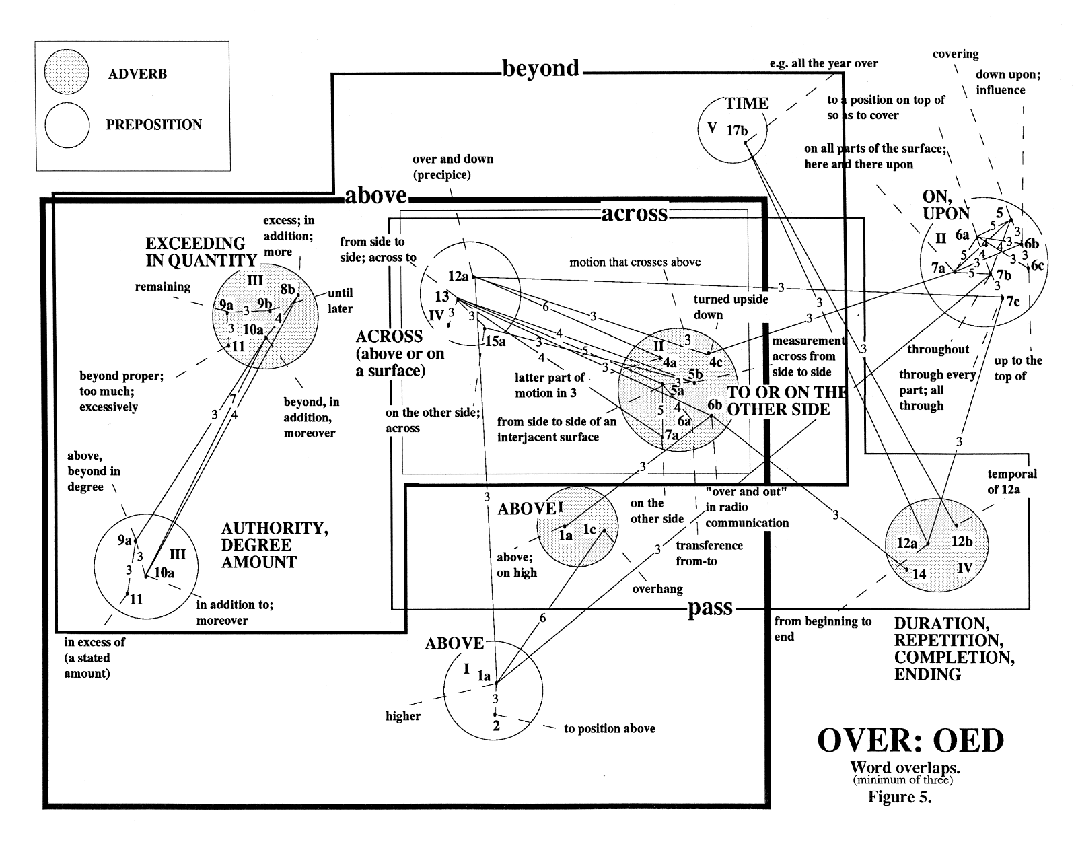
3.5 Etymology

The etymological section of OED (OED, p. 1057) gives the Sanskrit root of over as "upari/upara". "Upari" had the senses of "over, higher, more advanced, later". Notice that each of these senses can be construed as relating respectively to "position", "relation", "value comparison", and "time comparison". These notions coincide with the main OED and RIT groupings, discussed later.

The "upa-" part is etymologically related to ove -- as in, ab-ove and ove-r. "up" and "upper" may have the same origins as they share the "vertical/higher" sense -- as well as an obvious phonetic similarity.

Brugman and Lakoff note that the common cultural metaphor of "up is more" is relevant to interpretations of the meaning of words such as "over". This metaphor should be kept in mind as a minor theme throughout the rest of this discussion.

Comparison of Central Senses:

Brugman and Lakoff: ABOVE + ACROSS
RIT: ADDITION
OED: ACROSS TO
Ad Hoc Research: higher and DIRECTLY ABOVE
Etymology: HIGHER, MORE ADVANCED, LATER

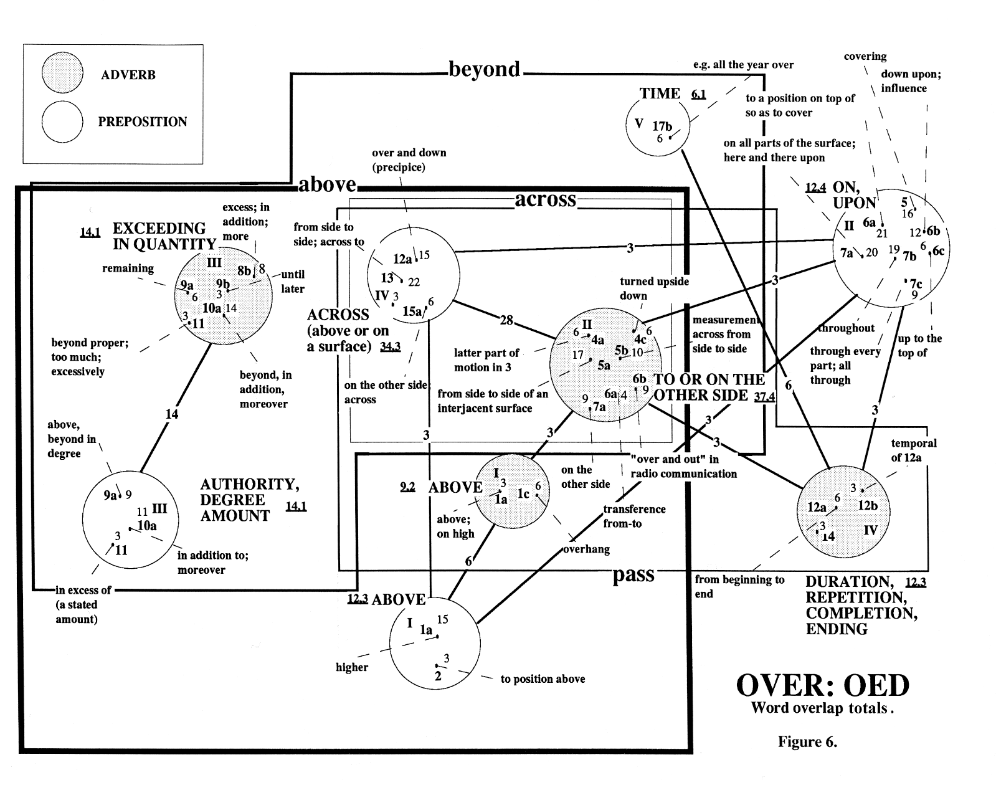
4 Analysis of the Networks

4.1 Analysis of the RIT Network:

"Addition" is a Category in RIT (Category 40). The semi-colon group in Category 40 which contains the word "over" also contains 37 other words which mean "additionally". For example, "furthermore", "also", "by the same token" and "moreover". Of the 37 words in Category 40, 10 are link words. That is the largest number of link words found in any category or semicolon group containing "over". As this appears to be an incongruent or counter-intuitive central sense I shall discuss it further in Section 5.6 of this paper.

What of "higher" and "above", and "above and across"? The "above" link word falls in six semi-colon groups. That is the most represented link word in terms of numbers of nodes or senses it links to or occurs in. Of this set of six semi-colon groups, two occur in Category 206, Height (i.e., Category 206 has two semi-colon groups containing both "over" and "above": "over, above, supra"; and "above, over, o'er, overhead"). Hence the Height and "above" sense, described as "ad hoc" is well represented.

The two approaches, "number of semi-colon groups" (referring to the discussion on Height/"above") versus "number of link words" (referring to the discussion on Addition/"additional") suggest two, possibly complementary dimensions of representation for senses: firstly the number of occurrences of a word (in terms of the number of senses that it participates in) and secondly, the number of words that co-occur in a particular sense. Thus, "above" with its many sense participations (semi-colon groups that it participates in) could be viewed as the most "pervasive" (and therefore perhaps most easily recalled or retrieved from memory) sense of "over", while "Addition", with its many link words (many connections to other senses), could be viewed as the central (though least easily discriminated) sense of "over". This idea is discussed further in Section 5.2.

In the RIT data, the second strongest sense, in terms of pervasiveness (number of senses which share a common word), is "past". This participates in five semi-colon groups. In terms of recurrence at the category level, Excess occurs the most often, with three senses. Tabulating, we get Table 1.

Category Dimension |  | Word Dimension
Excess | 3 | above | 6
Height | 2 | past | 5
Superiority | 2 | over and above | 4
End | 2 | beyond | 3
(all others) | 1 | extra | 3
 |  | throughout | 3
 |  | (all others) | 2

TABLE 1.

A complete listing may be found in Appendices A and B.

4.2 Analysis of the OED Network:

The OED data suggests that the second strongest sense is the "in addition to"; "excess"; "above and beyond in degree" sense of III 8b (adverb) and III 9a (preposition). These senses are notably disjoint (refer to Figures 5. and 6.) from the more central "across" sense. The common denominator that ties these senses to the central sense is the word "beyond". Exceeding in quantity or amount (in the sense of being past) is analogous to being past (refer to the RIT data and Figure 4.) or beyond a landmark or point, as in, "to or on the other side".

Looking at simply the count of link words in the OED data reveals a strong correspondence with the RIT data. The equivalent of RIT Category labels appear to be embedded in the text. In Table 2., those words which might, in my judgement, provide a meta-level of categorization (or organizing dimensions) of the senses, are underlined. Note that several of these do not have corresponding RIT Categories and that generally they are nouns.

There are other words in the OED sense definitions which have corresponding RIT Categories. "end", "high", "repeat", "cover" and "remaining" correspond to the RIT Categories "End", "Height", "Repetition", "Covering" and "Remainder".

OED Word | Count | RIT Category
above | 20
on | 14
beyond | 13
position | 11 | Location
excess | 10 | Excess
to | 10
surface | 9
up | 9
all | 8
in | 8
cross+across | 7
more | 7
pass | 7
side | 7
space | 7 | (Distance, Direction)
(across | 6)
addition | 6 | Addition
end | 6 | End
high+higher | 6 | Height
motion | 6
upon | 6
amount | 5
from | 5
(higher | 5)
part | 5
than | 5
time | 5 | Time
besides | 4
complete | 4 | Completeness
cover | 4 | Covering
down | 4
jump | 4
number | 4
remaining | 4 | Remainder
repeat | 4 | Repetition
through | 4
too | 4
upper | 4
again | 3
authority | 3
consideration | 3
cricket | 3
duration | 3 | (Time)
excessive | 3 | Excess
fall | 3
go | 3
later | 3
much | 3
of | 3
overmuch | 3
quantity | 3
sea | 3
take | 3
throw | 3
under | 3
whole | 3

TABLE 2.

5 Discussion:

5.1 Dictionary versus Thesaurus:

As mentioned under "Central Senses", the RIT sense of over+across is "across to". The "pass over" sense (as per Brugman and Lakoff) is listed elsewhere in RIT as phrases: Category 272 Travel, under semi-colon group 19:1, {traverse, go over, pass over, cover ...}, and Category 311 Overrunning, under 8:3, {pass over, cross, go across, ford}.

The apparent omission of the sense, "pass over", from the set of RIT over senses perhaps suggests the qualitative difference between thesauri and dictionaries. In a thesaurus, if a word or phrase cannot replace a particular word in a sentence then the word or phrase does not qualify to participate as part of a sense of that word. In a dictionary, on the other hand, a word or phrase which qualifies the subject word (e.g., "pass" or "cross" over) may be eligible to participate as part of one of the senses of the subject word. This blending of senses requires further analysis. Criteria are needed to decide when such a multi-word sense is a strict sense of the subject and when it is a separate but related (through its components) sense.

5.2 Categories and Word Sense Networks:

Brugman and Lakoff (p.480) point out that feature-based descriptions of senses, alone, are inadequate. In order to represent the relationships between senses a topological representation is needed (as mentioned earlier, what Brugman and Lakoff call a radial category). The networks described above have such a topological structure.

Referring back to the two dimensions apparent in the RIT data ("above" versus Addition, discussed in Section 4.1), the differences in dimension are analogous to the dimensions exhibited by categories, groups and classes. In a dictionary sense definition or in a zoological taxonomy there may be a set of defining characteristics (genus) and differentiating characteristics (differentiae). For (a simplified) example, birds have feathers and wings, and lay eggs, yet the first attribute recalled when the word "owl" is mentioned, appears generally to be "large eyes" -- the attributes which are the exceptions to the rule, rather than the attributes which the rule defines. The links which associate types of birds, as with the links used for constructing the RIT and OED networks, are formed by connecting "nodes" which contain common attributes/properties.

The senses in the RIT data which are most readily recalled appear to be the "peripheral" senses (the outer "attributes" of over) and it is the differentiating members of the set of synonyms in each sense (non-link words) which characterize the sense (Cf. Figure 4). Without elaborating further, it is possible that the dimensions mentioned above are equivalent to the difference in responses one gets when requesting from a person:

1. "What are the attributes of a bird?" versus
2. "What do you think of when I say 'owl'?".
(e.g., "What does over really mean" versus "What do you think of when I say 'over'").

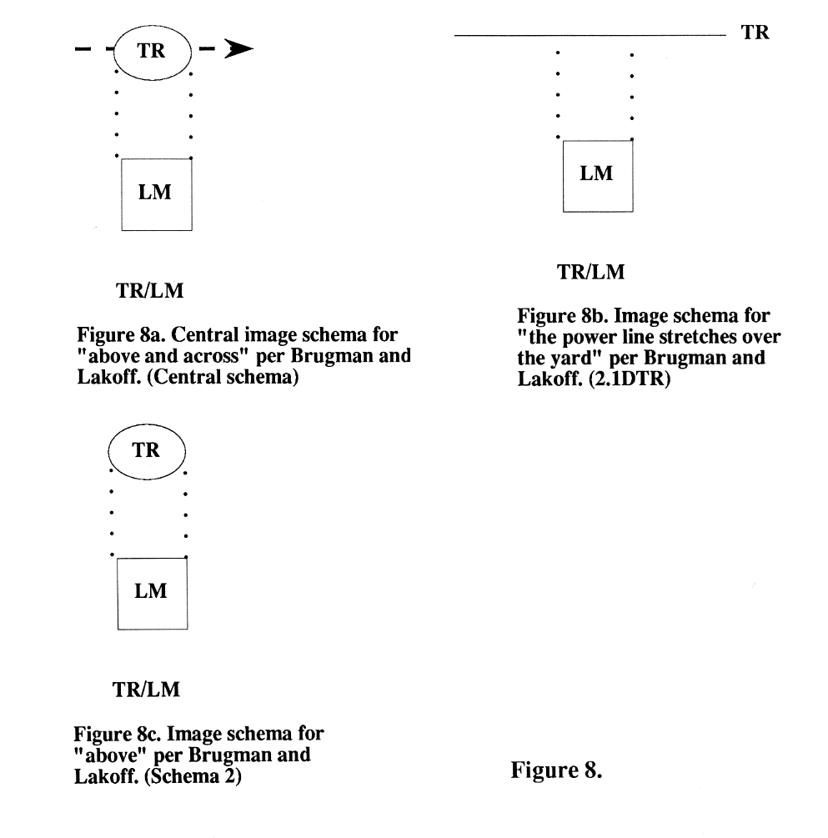
Also, as with the disjoint sets of word senses in the RIT and OED networks, the criteria for the inclusion of an animal in the set of birds may be irregular. A Kiwi has no wings, and feathers which barely qualify as feathers, yet has been taken to meet sufficient of the criteria to be called a bird. "again" is the criterion for the inclusion of the repetition sense of over, yet it has little in common with "upon" or "across".

5.3 Transformations:

Word sense transformations, as pointed out by Brugman and Lakoff, take a variety of forms. Concrete to metaphor mappings obviously utilize shared information (analogy). General to specific (or specific to general) involves a loss or increase in information. Counter-intuitively, the specific cases have more detail (information), while the general (more central) cases contain subsets (more restricted sets) of the information. For example in Figure 1. the senses toward the center of the network tend to have fewer attributes (or transformation codes), while those toward the periphery have more.

A third transformation "type" is the dimension shift described by Brugman and Lakoff (pp. 488-489). A shift from static to dynamic may simply be represented as a change in an element in an image schema from a line to a vector (from a "one-dimensional" trajector to a "two-dimensional" trajector, as Brugman and Lakoff put it), for example. That could be thought of as the addition of the time dimension, where the projection of the position of a moving (or more generally, changing) object is mapped as a trace in space (refer to the image schemas in Figure 8, taken from Brugman and Lakoff). "The cable stretches over the yard" has an image schema of a line in parallel to and above a plane, whereas "the bird flew over the yard" can be imaged by the same schema, but with an arrow at one end of the line, indicating at once, motion and the direction (or trajectory, in Brugman and Lakoff's terms).

It is noteworthy that it is common to represent a path or trajectory as a directed solid line and that we may so naturally add an end point (per Brugman and Lakoff, Figure 1.). Munoz, et al. (1991, p. 1358) describe topographical neuronal arrangements in the superior colliculis as being a motor map on which the amplitude and direction of neuronally encoded movement (during gaze shifts) vary continuously with location, moving to a final "zero" position containing neurons which were (for their particular experiment) active during fixation, i.e., co-ordinating our eye muscles to follow a moving object involves an internal map which is active in the same pattern as a vector or trajector. They also discuss spatial temporal transformations.

Rotation of planes, or change in spatial orientation, is discussed by Brugman and Lakoff (p. 492). For example, a veil over a face (schema #3RO -- RO is the code for "rotated") is the rotated image schema for a blanket over a bed (schema #3). Rotation relates somewhat to other types of dimension transformation. One way of interpreting the transformation of over word senses is shown in Figure 9. In as much as we as humans are able to mentally rotate and change perspectives with comparative ease, it is probable that many of the transformations of word senses involve this process. It is also possible that (vide Munoz, et al.) we make similar transformations across the temporal dimension.
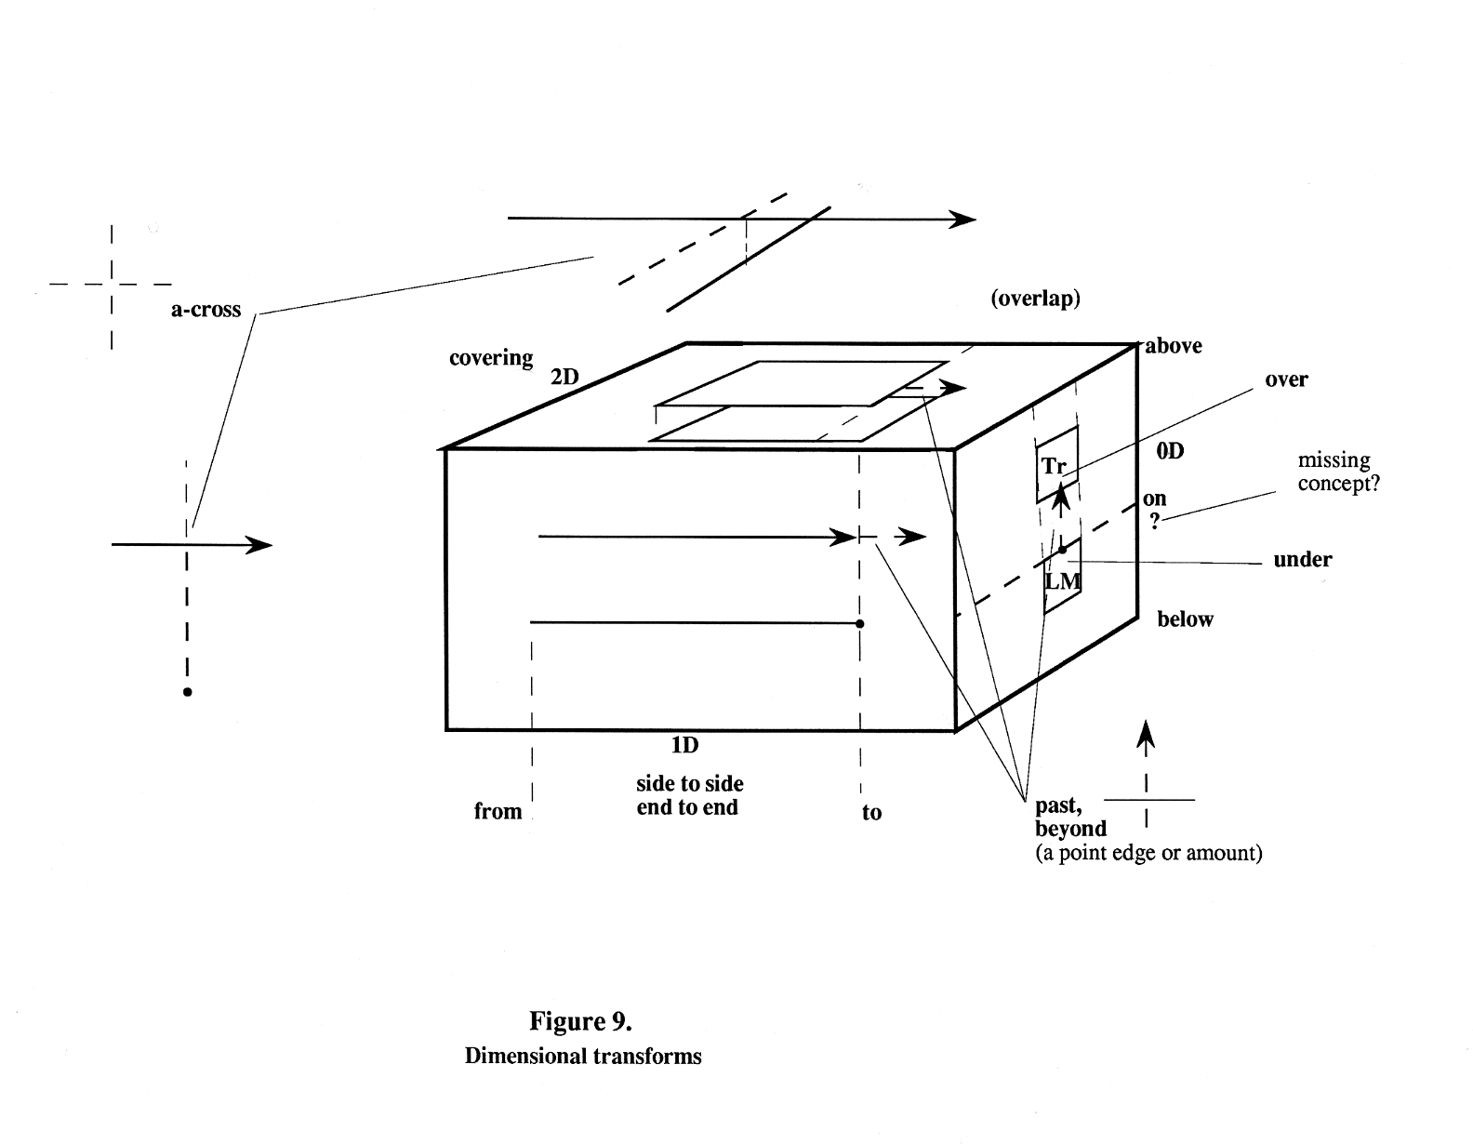
Referring to Figure 9., each face of the cube shows a different dimensional perspective. Ignoring the dimensions and perspectives shows clearly the possible basis of at least one set of image schema transformations. The schemas on each face (dimension) are the projection of the schemas on the other faces. The plane-above-plane is Brugman and Lakoff's image schema #3. With the extended arrow, it corresponds to #3PE ("it clouded over"). The line-above-line corresponds to #2.1DTR(referred to earlier in Figure 8b.), with the arrow, to #1.XNC ("the bird flew across the yard") and with the point and vertical dotted line added, to #1.XNCE ("to the other side"). The end of the cube contains #2 (the "above" schema) and #5 (the "excess" schema).

Obviously this is an over-simplification. Either the TR (trajector/subject) or the LM (landmark/object) can be of any dimensionality (including three-dimensional or time-dimensional). For example "a monument was built over the spot where he fell", can't be slotted into Figure 9., but yet doesn't contradict the principles demonstrated there.

Note that the "past" and "a-cross" aspects of the image schemas have an underlying common pattern which perhaps suggests that the intersection of the orthographic projection of a point is an element (or subschema) of past, across, and also of the central sense of over suggested by me earlier in the paper, i.e., it is the least common denominator.

Figure 10. takes a clockwise rotation perspective. A full rotation corresponds to Brugman and Lakoff's image schema #4 ("roll over"), running from point/situation 4 to 7 corresponds to #4.RFP ("fall over"). Further image schemas not identified in Figure 1., but present in senses in OED, are 5 to 8 ("over the precipice"), 7 to 11 ("bend over"), and others. The LM part of each situation is what Brugman and Lakoff call "reflexive". It is a part of the object in question as in, "head over heels" or "the log rolled over (itself)".

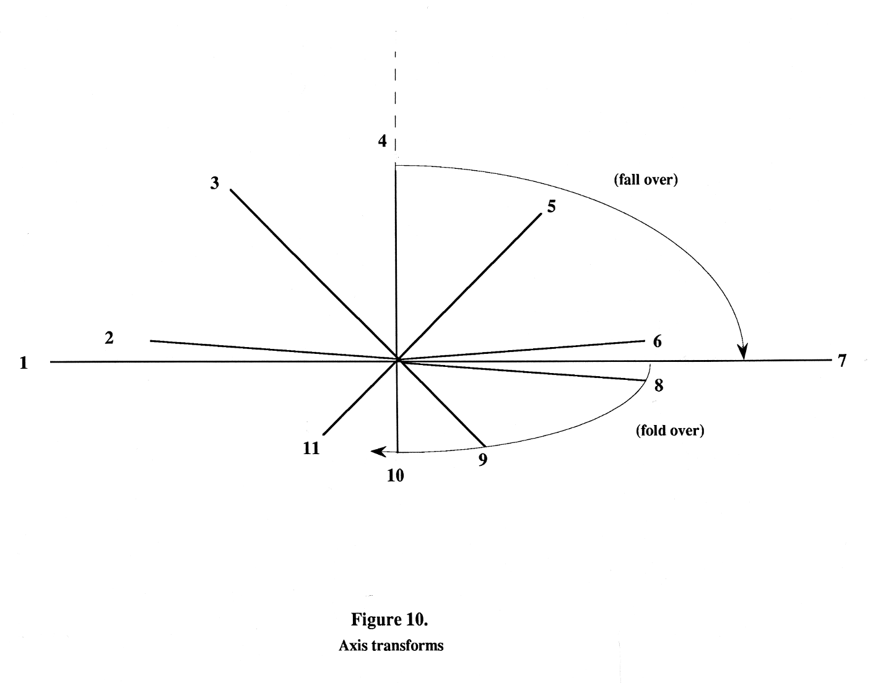
It is possible that "missing" or "unused" concepts could be identified by the methodical arrangement of image schemas. In Figure 9. the word "on" has no exact counterpart (referring to the zero-dimensional facet). "Underneath" and "beneath" do not quite match in symmetry and or complementarity -- there is no contact necessary in their semantics. "Underneath and against" is closer.

In similar vein, "after" is clearly related to past and beyond. In Dutch this serves as the word which describes the position of the back yard of a house from the perspective of some one standing in the front yard. "After the house is the back yard" (on the other side of or beyond the house). Perhaps this suggests that there are potential uses for some words (because their image schemas are congruent with particular situations) which are never actually applied. That is not to say that they could not be, might not be in the future (as the language shifts), or might not have been in the past. OED sense V 16 (prepositions) gives "Beyond in time; after. obs. exc. dial." as a sense of over.

5.4 Parts of Speech:

Previous research (Old, 1991) suggests that objects (nouns) in RIT tend to be denoted or characterized by few or even single words, while processes (verbs) tend to be denoted by several polysemous words, each of which tends to overlap with the meanings of both its neighbors (in the situation or context under scrutiny) and with other process-descriptive words. Figure 4. suggests a continuum of degrees of mutability and blending, from adverbs and prepositions to adjectives to verbs (and from previous research) to nouns. The OED data is not inconsistent with this observation (refer, for example, to Figure 3.).

Statistics from Jacuzzi's work on connectivity within RIT suggest that the number of nouns which participate in links is less than would be expected from their total numbers, while verbs are over-represented.

Simpson (1987), while discussing his index of polysemy (where the magnitude of the index for a given word is related to its degree of interrelation with other words), also noted that one-word nouns with a low index of polysemy are more likely to be nouns denoting physical objects than those denoting conditions or states.

I suggested earlier in this discussion that the generality of the underlying image schema of a word sense related inversely to its complexity (or amount of information). It may be that nouns describing physical objects have such a degree of complexity behind them (the objects they represent are comprised of a large set of complex image schemas and image schema transforms) that their generality is near zero. Conversely, prepositional (for example) word-senses may be characterized by few or even single image schemas which are so primitive (sensorially) that they participate as building blocks in the construction of many, more-elaborate word-senses.

This perspective on "part-of-speechness" may also account for such "transitional" parts of speech as gerunds, substantives, verbal adjectives, adverbial nouns and so on.

5.5 Subsets of Senses:

It was noted earlier that an object may be above (higher) than some landmark point, and yet not over it. Conversely, it is impossible to be over and yet not above, making this sense of over a subset of the strict (minimal) sense of above. "A-cross" is related to the verb "to cross" in a similar fashion. It is possible to either cross over or cross under a bridge. Either phrase satisfies the "X" image schema. However it is impossible to have gone across the bridge and to have also passed beneath it. Crossing implies the intersection of two vectors at some point, while across implies the intersection of the orthographic projection of some point. "Cross over", (synonymous with "across"), and "cross under" are therefore subsets of the sense (of) "cross".

Further, it is possible to be over (lacking the "X" schema) and yet not across, while it is impossible to be across and yet not over. It might be reasoned, therefore, that across is a subset of over. Similar reasoning places "above" as a subset of "higher". Above might be represented as an image schema which has volume spread in all directions except down below some point or level. An object can be "on" a table and "above" it at the same time. The object cannot be "on" and at the same time "higher (than)" it -- or can it?

Though it is difficult to define what the image schemas of above and higher might be, in the cases given above (where higher > above > over > across) the addition of a subschema or element (new information or complexity) to a word, reduces its generality i.e. the more complex the schema, the more specific (restricted) the minimal sense is. This relates back to the previous discussion about transformations.

This concept of high generality may be applicable to the words in the OED definitions, such as "position", which appeared to me to be candidates for OED category headings (discussed under Section 4.2, above). "Position" was located in OED senses that corresponded to RIT senses which had Category labels such as Location and Distance. I believe that this area merits further study.

5.6 Central sense of RIT: Category 40.

Astronomers searching the sky for dark matter and black holes map the pale, distant blue galaxies which provide a backdrop to the night sky. In order to identify a black hole or other dark mass (which cannot be sensed directly), astronomers search for distortions in the blue galaxy fabric. Where a dark mass occurs, the light from the blue galaxies passing it is distorted and bent so that what was a series of near spherical bodies appears as a set of ellipses oriented to the dark mass like a halo. Category 40, semicolon group 10:1, with its many unexpected connections to over, may be of this nature. It is identifiable by the company it keeps, rather than directly as an obvious sense of over.

In fact, any sense which was near or beyond the threshold of our sensory perceptions might be difficult to characterize by a small set of synonyms or, alternatively, have an image schema which can participate in transitions to many other image schemas. Either way, any sense which had a very high degree of generality would either be identifiable as a highly polysemous word or in the second of the complementary dimensions discussed early in this paper (the first was the number of occurrences of a word in terms of the number of senses that it participates in, while the second was the number of words that co-occur in a particular sense) might be identifiable by a large set of synonyms. Previous research on RIT suggests that this is the case. For example, Category 171 Tendency, 3:1, has many highly polysemous words i.e., {tend, incline, dispose, lean, trend, set, go, point, head, lead ...} and is, incidentally, the central sense of the polysemous word "lead" (to guide) in RIT.

6 Conclusion:

The meta-level description data which was removed from the original OED text ideally should not, be treated as noise in the examination of dictionary word senses. Analysis of this data could provide heuristics for more detailed automated extraction and discrimination of word senses from dictionaries.

Not discussed here is the concept of distance among senses. What does a transform "cost" in a dynamic system? Are the most complex the most costly? In a machine (in the absence of a sensory and neural substrate), how are the transitions to be made? Precisely what does ambiguity mean in this context? Are there degrees of ambiguity (intuitively, yes)? How are these to be quantified? To my knowledge, a distance metric which accurately characterizes semantic distance does not yet exist. That would be required, I believe, before further progress along these lines can be made.

What do subset, ordering, and category mean in this context? Is the pattern which shows up in these networks not so much category-like as the source of why we as humans must categorize? Are these emergent image schemas which result from the Gestalt of many senses? What of "genus and differentiae", or the mathematical terms "set and relation"? Is all mathematics an artifact of human cognitive processing rather than of the physical world? Is there a difference?

I and Brugman and Lakoff have described many of the transforms as dimensional. Is this really meaningful, or are dimensions not so much partitions of reality, as indicators of transitions between primitive/atomic image schemas? Is there a difference? What rules govern the production and structuring of image schemas? What rules govern the combination of image schemas?

Are sensory primitives at the heart of the elements of senses? It is possible that senses partition this multidimensional domain or act as co-ordinates in it. It is certain that motor aspects of the brain/CNS, though not discussed here, participate as fully in sense structures as sensory aspects do. The paradigm explored here has been visually oriented, but is vision at the heart of the system?

Only empirical data can help us to answer these questions with certainty as, though introspection gives insight (to persevere with the paradigm), it does not give measure.

References

Bryan, Robert M., Abstract Thesauri and Graph Theory Applications to Thesaurus Research. In Sally Yeates Sedelow, ed., Automated Language Analysis, University of Kansas, Lawrence, 1973.

Brugman, Claudia and Lakoff, George, Cognitive Topology and Lexical Networks. In Lexical Ambiguity: Perspectives from Psycholinguistics, Neuropsychology & Artificial Intelligence, ed. S. I. Small, G. W. Cottrell and M. K. Tanenhaus, Morgan Kaufmann, San Mateo, California, 1988, pp. 477-508.

Jacuzzi, Victor S., Modeling Semantic Associations Using the Hierarchical Structure of Roget’s
International Thesaurus, Oral Presentation, Biennial Meeting, DSNA, Columbia, MO,
1991.

Munoz, Douglas P., Pelisson, Denis, and Guitton, Daniel, SCIENCE, vol. 251, March 1991,
pp. 1358-1360.

Old, L.J., Analysis of Polysemy and Homography of the Word "lead" in Roget's International Thesaurus: In Proc. of the Third Midwest Artificial Intelligence and Cognitive Science Conference, University of Southern Illinois at Carbondale, April 1991, pp. 98-102.

The Oxford English Dictionary, Second Edition, Ed., R.W. Burchfield, Clarendon Press, Oxford, 1989, Volume X, pp. 1056-1140 (over - over-zealous).

Roget's International Thesaurus, 3rd Edition, New York, 1963.

Simpson, W. F., A Measure of Polysemy on Roget's International Thesaurus, Fourth Edition, Ph.D. Dissertation, University of Kansas, 1987.

Appendix C.

OED "over" senses

{ = indicates this writer's comments. † = obsolete usage)

{p. 1056, Vol X}

ADVERB

over (euve(r)), adv. Forms: ...

[Com. Teut.: ...O.E. ...{all levels of Dutch, German and English; Fresian, Gothic Norse Swiss, Danish and Greek υπερ {uper}: adverb, preposition and prefix} ...

Skr. upari adv. and prep., locative form of upara adj. 'over, higher, more advanced, later', comparative form of upa, in Teut, ufa-, uf-, whence the adverbial ufan (see OVENON, ANOVEN) and be-ufan, bufan, with the compound a-bufan, ABOVE. Over was thus in origin an old comparative of the element ufa, ove, in ab-ove. Besides its uses as a separate word, over- is in all the Teutonic languages an important adverbial prefix see OVER-.]

I. With sense Above, and related notions.

1.
a. Above, on high.

b. Above on a page; on a previous page.

c. After hang, project, jut, lean, and the like (in reference to space beneath: see OVER prep. 1); hence ellipt. projecting, leaning, or bent forward and downward.

2.
a. Above so as to cover the surface or so as to affect the whole surface: with such verbs as brush, cover, clothe, ... paint, .... See also ALL OVER.

b. To be (someone) all over; to be very characteristic of (that person); to be exactly what one might expect of (someone specified).

{p. 1057}

II. With the sense To or on the other side.

3.
Indicating a motion or course that passes or crosses above something, usually rising on one side and descending on the other; as to climb, jump, run, flow, boil over, to look over, shoot over, throw something over; sometimes (b) esp. with the sense of passing above and beyond, instead of reaching or hitting, and so fig. of going beyond, exaggeration.
{(b) 1599 Shaks. Hen. V ...}.

4.
a. Hence used of the latter part of the motion of course described in 3, corresponding to the position in I c {?} = over the edge or brink and down, as in to fall, jump, throw oneself, push any one over (cf. over a precipice, OVER prep. 12). Also,

b. of a similar movement from the erect position, without reference to any brink, as in to fall, tumble, topple, knock a person, a vase, etc. over; and

c. in to bend, double, fold, turn, roll a thing over, in which the upper surface is turned forward (or laterally) and downward, so as to become the under, i.e., is turned upside down. to roll or turn over and over, i.e., so that each part of the surface in succession rolls forward and downward, and is alternately up and down.

5.
a. From side to side of an interjacent surface or space: in early use esp. said of crossing the surface of the sea or other water (closely akin to 3), a street, a common, or other defined tract; in later use often said merely of traversing the space or distance between two places, and so adding some notion of completeness to go, come, run, etc.; e.g. "Take this over to my friend's house".

b. Of measurement: Across from side to side; in outside measurement.

c. Cricket. ... [exchange of players; bout; innings]

6.
a. From one person, side, party, opinion, etc., to another: expressing transference or transition; esp. in deliver, hand, bring, make, take over, go, come, pass over, give over; see GIVE v. 63. (see also GET v. 74e).

b. Used in radio communications to indicate that the speaker has finished speaking ... over and out. ... over to you ...

7.
a. On the other side of something intervening, e.g. a sea, river, street; hence, merely, on the other side of some space, at some distance.

b. over against (prep. phr.): opposite to. So over anenst dial., †overynentes obs.

III. With the notion of exceeding in quantity, etc.

8. Above or beyond the quantity named or in question.

a. Remaining or left beyond what is taken.

b. Present beyond the quantity in question; excess, in addition, more. over or under,
†over or short; more or less.

9.
a. Remaining or left unpaid, unsettled, or uncompleted after the time of settlement; remaining for the time being; left till a later time or occasion; esp. with remain, lie, stand, hold, leave.

b. Until a later time or period; till the next season; overnight.

† 10.
a. Beyond or in addition to what has been said; more than that, moreover, besides; further.

b. So †over and besides; also OVER AND ABOVE.

11.
Beyond what is normal or proper; too much; excessively; too. Cf. OVER AND ABOVE B.2.
Modifying adjs. and advs. and now usually hyphened or combined, as over-anxious, overmuch: see OVER- 28, 30. In Sc. and north. Eng. dial. (ower, owre) the regular word for 'too', and always written separate, as ower muckle.

IV. Of duration, repetition, completion, ending.

12.
a. Through its whole extent; to the end; from the beginning to end; esp. with read, repeat, say, tell, reckon, count; with talk and think, this passes into the notion of detailed consideration.

b. For temporal phrases of the type 'all the year over', which partly belong here, see OVER prep. 17 b.

13. Expressing repetition.

a. orig. over again, or with numeral adv., as twice or thrice over. ... To be verbose and to say the same thing twice over.

{p. 1058}

b. over in the sense of 'over again'.

c. over and over, over and over again, repeatedly, many times over.

14. Past, gone by, finished, done with, at an end. Phr. over (and done) with: completed, finished; dispensed with.

15. In addition to the prec. senses, over is used idiomatically with many verbs, as GIVE, PASS, PUT, THROW, WALK, etc. See these verbs. {'give over' = "don't tease me" = 'get away': 'put over' = "to cross or cheat someone"}.

PREPOSITION

... FORMS: see prec. [The same as OVER adv. with object.
OE. ofer was const. with dative or accusative, the former orig. in the sense of position, the latter in that of motion to. There are however several uses in which these distinctions are not clear, which app. led to looseness in the use of the cases generally, so that in many senses either case was used with no apparent difference of sense, the preponderance being in favour of the accusative.]

I. In sense above.

1.
a. Above, higher up than. Said either of position or motion within the space above; also, after hang, project, jut, lean, etc., in relation to anything beneath.

b. In various fig. uses.

c. over (one's) signature, name, etc.: with one's signature, etc. subscribed to what is written.

†2. To position above.

3. Idiomatic use. In (or into) a position in which water, or the like, rises above one's shoes, boots, ears, head, etc. Also fig. See also OVER SHOE.

4. The spatial sense 'above' passes into other notions: the literal notion is

a. combined with that of purpose or occupation, as in over the fire, a bowl, a glass;

b. sunk in that of having something under treatment, observation, or consideration, as in to watch, or talk over, makemerry over.

†c. With reference to, regarding, concerning, about (a subject of discourse, thought, feeling etc.). {to mull over}

II. In sense up, upon.

5. On the upper or outer surface of; upon: sometimes implying the notion of supported or resting upon, sometimes (now more frequently) that of covering the surface.

6.
a. To a position on the surface or top of, or so as to cover; upon (with verbs of motion).

b. fig. Upon, down upon, as an influence.

†c. Up to the top of, up to.

7.
a. (Position) on all parts of the surface of; everywhere on; here and there upon. Often strengthened by all, now esp. all over. (See also ALL OVER adv. phr. I c).

b. (Motion) from place to place on the surface of; to and fro upon; all about; throughout. Often all over.

c. Through every part of, all through. (Sometimes including the notion of examination or consideration: cf.. 4.)

d. In the above senses (esp. a. and b.) often placed after its object, esp. when this is qualified by all or the like. (Cf. through).

e. Math. (Defined or expressed) in terms of (the elements of); esp. having elements with coefficients or co-ordinates in, or having elements with coefficients or co-ordinates in.

III. Above in authority, degree, amount, etc.

8. Above in authority, rule or power; with sbs., as king, lord over,; jurisdiction, rule, triumph, victory over; adjs., victorious over; vbs., to reign, rule triumph, appoint or set any one over.

9.
a. Above or beyond in degree, quality, or action; in preference to; more than.

{p. 1059}

†b. Conjunctively (by ellipsis). Above or beyond what .... Obs.

†10.
a. In addition to, further than; beside, beyond. over this, over that, moreover, = L. praeterea.

b. So far † over and besides, †over and beyond. (See also OVER AND ABOVE A. 3.).

11. In excess of, above, more than (a stated amount or number).

IV. Across (above, or on a surface).

12.
a. Indicating motion that passes above (something) on the way to the other side. Sometimes expressing only the latter part of this, as in falling or jumping over a precipice, i.e. over the edge or brim and down.

b. over the wicket: see BOWL v. 4 b.

13. From side to side of a surface or space; across, to the other side of (a sea, river, boundary etc.); from end to end of (a line), along; by means of (a telephone, radio communication, or the like); = ON prep.. I d.

† 14. fig. In transgression or violation of; in contravention of, contrary to. obs.

15.
a. On the other side of; across (of position).

b. Having recovered from an illness, disease, or the like). Cf. GET v. 46 b.

V. Of time.

16. Beyond in time; after. obs. exc. dial.

17.
a. During, all through. (In mood. use transf. from space.)

b. The OE. use in quot. 893, is sometimes expressed in ME. and mod Eng. by over following the time phrase; as in all the year over, the whole day over. Cf. the corresponding local use in sense 7 d. In the temporal use, over, being appended to a phrase which is itself an adverbial adjunct, may with equal propriety be viewed as an advb.: cf. 'he works in the field all day', with 'he sings at his work all day over', i.e. all day from beginning to end.

† 18. During or in the course of the (eve or night) preceding ; on the preceding (evening night). Obs. except in OVERNIGHT.

SUBSTANTIVE {noun or adjective used like a noun - nominal}

† over, ovre, sb. 1 Obs. [Com. W. Ger.: ... see kluge] A border or margin: spec. of the sea or a river: the shore, the bank.
Beowulf (Z.) 1371 ...

1 over, sb.2 [Absolute use of OVER adv.]

1. (nonce-use f. OVER adv. II.) That which is excessive; an excess, extreme.

2.
a. An amount in excess, or remaining over; an extra.

b. pl. Printing. Copies printed in excess {...}

3. An act of going over or across something; a leap over a fence, etc. in hunting.

4. Cricket (f. OVER adv. 5c) The number of balls bowled from either end of a wicket. {...}

5. Mil. (chiefly pl.). A bullet, shell or other missile that passes beyond its target. colloq.

ADJECTIVE

over (euve(r)), a.. Forms: ...

{p. 1060}

{...spelling ... ufera, ofer ... overlippe ... similarity of spelling of original adv. and adj. forms led to adjectival use of the adverbial prefix e.g. 3, 4}

1. The upper, the higher in position.
Only attrib. prec. by the or an equiv., and used of one of two things, the other being the nether, lower or under. Now obs. or dial. exc. as preserved in com., and in place-names of villages, farms, fields etc.

b. Placed so as, or serving, to cover something else; upper, outer.

2. fig. Higher in power, authority, or station; upper, superior. In existing words usually written in comb. as oversuperior, overlord; see OVER- 2 and the Main words.

3. That is in excess or in addition; remaining beyond the normal amount; surplus, extra. (See OVER adv. 8, OVER- 19.)

4. That is in excess of what is right or proper; too great, excessive.

VERB

over. v. Also north. and Sc. our, ower, owre. [f. OVER adv. Cf. L superare.]

†1. trans. To make higher (in amount ); to raise, increase. In quot. 1602 absol. To go to a higher figure (by so much). Obs.

2. To leap or jump over; to clear.

†3. To get the better of, to master. Sc. Obs.

4. ellipt. To get over; to pass over. dial.

PHRASE

over and above, phr. [The two words used pleonastically for emphasis]

A. as a prep..

1. Above in rank, in a superior position to; = OVER prep. 8. rare.

2. In addition to, besides; = OVER prep. 10.
3. More than; = OVER prep. II. rare.
B. as adv.
1. In addition, besides; = OVER adv. 8, 10.
2. (Qualifying an adj.) Overmuch, too much, too; = OVER adv. II ... Obs. exc. dial.
b. attrib. or as adj. Overmuch, too great, excessive; = OVER a. {adj} 4 ... rare.

Though I will not discuss Measure Theory further in this paper, the duals of these graphs (where the nodes are represented as links and links as nodes) open the possibility of forming neural networks of words directly from sense definitions. A suitable metric for semantic distance is required.

